Final Project Assignment Report

3D Reconstruction from Stereo Images

BY

Rohit Das

National Taiwan Normal University

[61047086s@ntnu.edu.tw](mailto:61047086s@ntnu.edu.tw) , +886-905023713

**Introduction -** Reconstruction of 3D object from multiple stereo images

**Problem #1 –** Construct 3D data from multiple stereo images

**Steps –**

* Calculate the brightest point on left image
* Calculate epipolar point
* Take the column index from left image
* Put it as the index value of the same Right image
* Calculate the Right image pixel value from that index
* Divide with projection matrix to get the 3D value
* Print it on a .XYZ file.

**Challenges Faced –**

* Some parts of the model are not getting reconstructed properly.
* Tried minimizing the brightness overall to get the data properly.
* Tried minimizing the shortest distance to take points.
* Tried minimizing the outlier to get better accuracy.

To my demise, it didn’t work as expected.

**Experiment Result –**

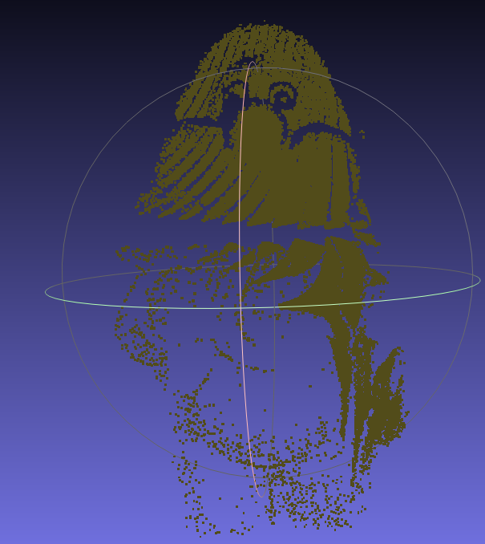

**Problem #2 –** Reconstruct texture from a colour image

**Steps –**

* From the previous problem store the 3d points
* Take more than 6 points from object point and image point (texture image)
* Calculate the projection matrix
* From the estimated matrix try to find out the 2d points from the given 3d points
* Extract the RGB values
* Write the data in XYZRGB format in a .txt file

**Challenges Faced –**

To my demise, it didn’t work as expected.

* The cv::projectpoints function finds the 2d point to 3d point but since the projection matrix is estimated, the 2d point estimation from point cloud was not that accurate
* The image has been read in BGR format. cv::Cvtcolor function solved this problem.

**Experiment Result –**

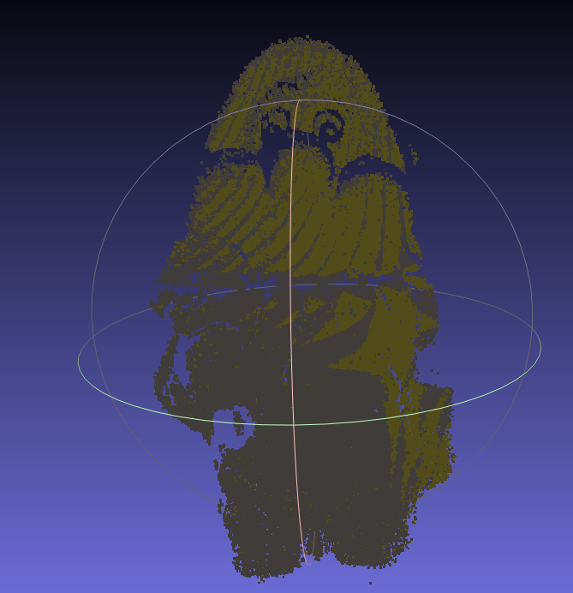

**Conclusion –** This project was very interesting cause this contains an overall summary of every chapter and information taught to us till now. I am really grateful to professor for giving us this roller coaster experience. The second problem of this project was quite difficult to implement. To my demise, it didn’t work quite well. But I am satisfied with my result.